The Business Analyst role in the SDLC

Contents

Introduction to the SDLC 2

Definition of SCLC 2

Steps in the SDLC 2

SDLC Diagram 3

The Business Analyst role in the SDLC 4

Methods of Documenting Requirements 4

Use Case 4

User Story 4

Wire Frame 4

Prototype 4

The Requirements Management Plan 5

Appendix – Font Information 5

Version History 5

# Introduction to the SDLC

The SLDC is a model that has been used by many professionals to delivery software development.

## Definition of SCLC

The SLDC stands for Software Development Life Cycle and is a model for software development, organized in a series of phases. As it is a model, it can also have different names as *Solution* Development Life Cycle and this extend to its phases, but they are describing the same type of work from different perspectives. The following sessions describes the BA work in each phase of SLDC.

## Steps in the SDLC

### Context

Where Business Analyst need to understand the main objective behind the development. In this phase is necessary to understand the parties involved, systems affected and stakeholders.

### Requirements

After defining the objectives and creating the context for the software, is important to define the requirements. Translate objectives, business needs and stakeholder needs into usable requirements.

### Design

In this phase, Business Analysts will draw mock ups from screens or flowcharts from business process. This is important so stakeholders can visualize the final work and validate the work done, before development starts.

### Development

In development phase, Business Analyst must to guide developers through the requirements. Also, share all the information gathered in previous phase so the whole team can have an equal understanding of the objectives and needs.

### Testing

This is the validation part and Business Analysts must to develop a reliable testing plan by identifying all the possible testing scenarios. Testing results must to be documented and validated with stakeholders.

### Deployment

Business Analysts should also get involved in deployment phase, making sure that versioning is done correct and the software is deployed in pre-production/production environments.

### Maintenance

The phase after system is delivered and operational. It might include changes in some functionalities or minor corrections.

# SDLC Diagram

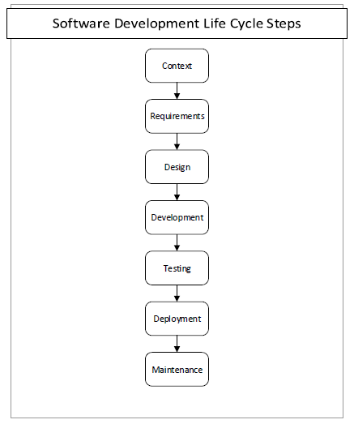

# The Business Analyst role in the SDLC

| Step | BA / BSA Involved?  (Yes, Partly, No) | If Yes or Partly,  Brief Description of Role of BA / BSA in this Step |
| --- | --- | --- |
| Context | Yes | Actively gathering all the needs and objectives. |
| Requirements | Yes | Translating the needs into requirements. |
| Design | Yes | Designing the solution, creating mock ups for visualisation. |
| Development | Partly | Sharing knowledge among developers and aligning results. |
| Testing | Yes | Developing a solid testing plan. |
| Deployment | Partly | Use context knowledge to coordinate deployment and communicating stakeholders of obstacles encountered. |
| Maintenance | Partly | Guide support team and developers to investigate issues and perform changes when required. |

# Methods of Documenting Requirements

## Use Case

Use case documentation must contain the main flow of the process. It also describes the alternative flows for a process.

## User Story

Begin by identifying who is affected by the requirement, then define what the user must to do and finally describe the objective to be accomplished.

## Wire Frame

A visualization tool to draw screen mockups. Draw all the required information in software screen.

## Prototype

Might be compared with wire frame, but this is a functional version containing all the information from a software and its basic navigation as well.

# The Requirements Management Plan

[Short paragraph on Requirements Management Plans]

This document defines the purpose in writing the requirements in a project. It also identifies the stakeholders involved in requirement collection, review and approval. In addition, it contains all the procedures to change requirements, approach requirement analysis. Usually, this document is written in the requirement analysis phase.

# Appendix – Font Information

| Font | Brief Description of the characteristics of the font  (no more than 2 sentences for each description) |
| --- | --- |
| Arial Tahoma | Has a simple looking. Also, wide used in modern days. |
| Courier New | Very close to old typewrite machines. |
| Tahoma | An Arial font with different name. |
| Times New Roman | It is a popular font in book printing. |

# Version History

| Version | Date | Status | Description | Author |
| --- | --- | --- | --- | --- |
| 01 | 21 Feb 2017 | Draft | Draft based on the assignment template | Danilo |
| 02 | 21 Feb 2017 | Draft | Review | Danilo |
| 03 | 21 Feb 2017 | Final | Final edit | Danilo |